Unblocking the Java Run Environment in your computer to run HADES Applets
If you find this problem when trying to run HADES Java Applets:
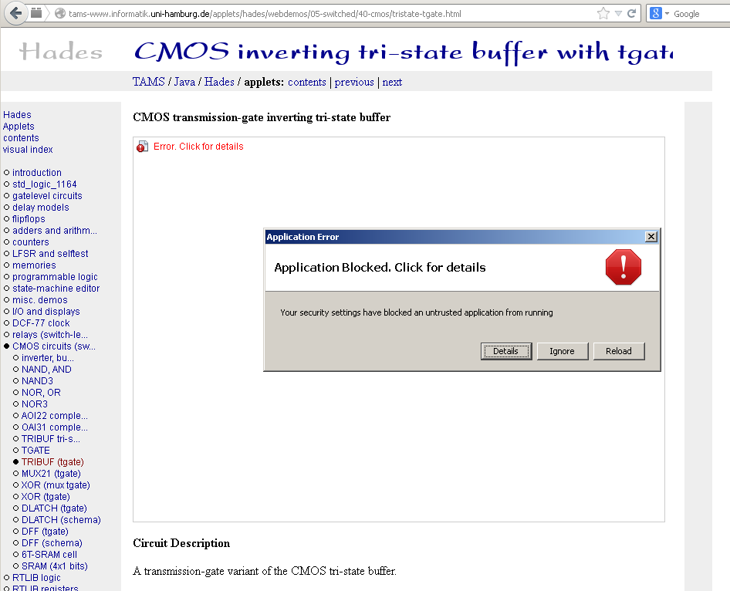

Find the window Control panel Java:
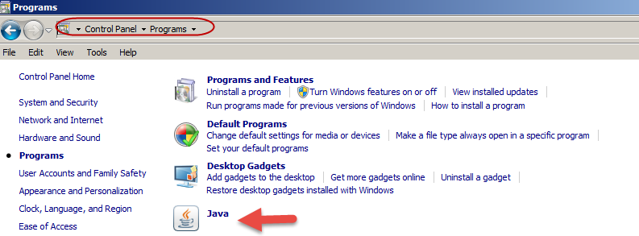

And then, set the “Medium” security level:
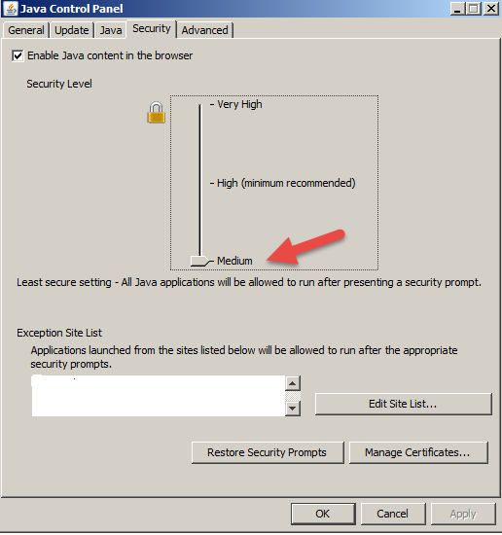
And, finally, run the Java applications clicking “run” when the system prompts the alert window:
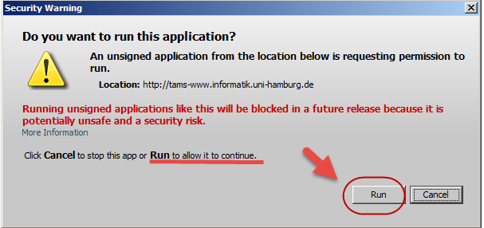
September 2020: The latest Java Runtime Environment to download is the Version 8 Update 261.

Another way is:
Keep the security level to “high” and add the HADES address
https://tams.informatik.uni-hamburg.de
In the exception site list below in the same window. This procedure may be better to suit new Java updates.
